

STATEMENT OF ADVICE

Financial Planning Strategy
Prepared for:

Michael & Patricia McMillan
Of

5 Anvil Place

Attwood VIC 3049

Mobile: 0497 798 610 (Michael)
0408 378 185 (Patricia)

Email: mkmcmillan@bigpond.com

Prepared on:

7th June 2017

By your Adviser:

Andrew Lord B Bus (Acc), Dip FS (Fin Plan)

Lakeside Financial

Level 1, 99 Bay Street
Brighton VIC 3186

Ph: 03 9596 5111 Fax: 03 9596 3222

Email: andrew.lord@lakesidefinancial.com.au
Authorised Representative # 324798
Pareto Group Pty Ltd
ABN 11 155 278 078 Australian Financial Services Licensee No. 418700
1/99 Bay Street, Brighton, Vic, 3186
Ph: 03 9596 5111 Fax: 03 9596 3222
What this document is about
This Statement of Advice (or SoA) is an important document.
- It provides you with information about our advice so you can make a decision about implementing the advice.
- It should be read in conjunction with other documents such as Product Disclosure Statements and our Financial Services Guide.

What to do after reading this Statement of Advice
Please contact us.
- If you have any questions.
- If we have omitted, overlooked or incorrectly understood any of your relevant circumstances.
- When you are ready to implement the recommendations.
- Or, if you decide you want to do something else and need our advice or assistance.

07/06/2017

Michael & Patricia McMillan
5 Anvil Place
ATTWOOD VIC 3049

Dear Michael & Patricia,

I am pleased to enclose your Statement of Advice (SoA).

It is an important document that you should read and understand before making a decision to proceed further.

We have based the strategies and recommendations in this document on our understanding of your current personal and financial position. If any of this information does not reflect any part of your current position, goals and objectives please advise us immediately and we will make the necessary changes.

The SoA sets out our recommended strategies to address your needs, together with a recommended course of action to implement these strategies.

When you are ready to proceed, we would be very happy to help you with the implementation of the advice, including the completion and lodgement of application forms and other documents.

Please note, our recommendations in this Statement of Advice are valid for 30 days from the date on the cover of this document. If your circumstances change before you implement our recommendations, or if you don’t act on them within 30 days, they may no longer be appropriate for you. If that happens, please ask us to review your situation again before you take any action.

Once implemented, we should review your situation on a regular basis to ensure we make the most of any changes that may impact on the strategies I have recommended for you.

Yours sincerely,

Andrew Lord

B Bus (Acc), Dip FS (Fin Plan)
Authorised Representative No 324798 of
Pareto Group Pty Ltd
Table of Contents
Financial Planning Strategy 1
Purpose of this document 4
Timeframe for our advice 4
Check for accuracy 4
Limitations of our advice 4
Product selection 5
Introduction 6
The Scope of Our Advice 6
Our Investment Recommendations 7
Your Adviser 7
The Planning Process 7
Executive Summary 8
Your Goals and Objectives 8
Recommendation Overview 8
Anticipated Outcomes 9
Future Strategies 9
Personal Information 10
Personal Details 10
Health Details 10
Employment Details 10
Estate Planning 10
Superannuation Assets 11
Income and Expenses 12
Your Investor Risk Profile 14
Strategy Recommendation 15
Retirement Planning 15
Superannuation Funds 16
Transition to Retirement 17
Pre-Retirement Income Stream 17
Salary Sacrifice to Superannuation 19
Reversionary Pensions 21
Superannuation Contribution Limits 22
Investment Recommendations 23
Current Portfolio 23
Proposed Portfolio 24
Projected Portfolio Compared To Benchmark 25
Performance 29
What is paid to your adviser 33
Upfront and Ongoing Fee Disclosure 33
Disclosure Statement 34
Summary 37

Purpose of this document

The following Statement of Advice (SoA) is an outline of the financial plan discussed with your financial planner. It details the recommendations needed to execute your plan and achieve your financial objectives.

Timeframe for our advice

Our recommendations in this SoA are valid for 30 days from the preparation date on the cover of this document. If your circumstances change before you implement our recommendations, or if you don’t act on them within 30 days, they may no longer be appropriate for you. If that happens, please ask us to review your situation before taking any action.

Check for accuracy

This SoA is based on the information you provided. Please read the document carefully, checking that your details are correct and that no important facts are missing. If anything is wrong or missing, please let us know immediately—otherwise our advice may be based on incorrect information and may not be right for you.

Limitations of our advice

We cannot give advice on:
- Trust or business structures | - Direct share or property purchases
- Taxation | - Legal matters
- General insurance

Please don’t consider any of this document’s recommendations to be advice in any of these areas. If you need advice in these areas, please see a qualified professional in that field.
Assumptions we've made

When giving advice, we make certain assumptions to demonstrate how the advice could affect your financial situation. We've based our advice on economic information and legislation that was current when we prepared your SoA.

All dollar amounts in this SoA are in today’s dollars, even when we mention future income, expenses, investment amounts and so on. Naturally we can’t predict what future inflation rates will be, so we can only make assumptions based on past trends. Also, all amounts listed in this document are “p.a.” (per annum) unless otherwise stated or implied.

Product selection

We are committed to giving you the best products for your situation. When preparing your advice we considered and recommended only those products on Pareto Group’s “Approved Product List”. This list was compiled by a dedicated Investment Review Committee, which regularly reviews it. To see the complete product list, please ask us.

Introduction

You are entitled to receive a Statement of Advice (SoA) whenever we provide you with any personal financial advice. Personal financial advice is advice that takes into account any one or more of your objectives, financial situation and needs.

This SoA is a record of the personal financial advice provided to you and includes information on the basis on which this advice is given, information about remuneration including fees, any other benefits and any interests, relationships or associations which might influence the making of the advice.

If this advice includes a recommendation to you to acquire a particular financial product (other than securities) or an offer to issue or arrange the issue of a financial product to you, we will also provide you with a Product Disclosure Statement containing information about the particular product to help you make an informed decision about that product.

The Scope of Our Advice

In this statement of advice, the main focus is on:

- Retirement Planning
- Superannuation
- Transition to Retirement
- Salary sacrifice

This advice is based on information we have obtained from you. You must ensure the information is accurate and complete. Otherwise, this advice may be based on inaccurate or incomplete information relating to your investment objectives, financial situation or needs. You must therefore assess whether the advice is appropriate, in the light of your own individual investment objectives, financial situation or needs.

You recognise in each of the areas of advice we provide, we only provide advice to the extent we are able to under the relevant legislation.

Our Investment Recommendations

In respect of the specific investments we recommend as part of our advice you are entitled to a 14 day cooling off period for your initial investment. A cooling off period generally means a period of time after which you have provided your capital for investment, where you can change your mind and request for your capital to be returned to you.

Each fund manager or investment provider may implement the cooling off period in a slightly different manner. Therefore we recommend you refer to the Product Disclosure Statement for each of the recommended investments in order to understand the operation of each provider’s cooling off period.

Your Adviser

At any time should you have any questions or concerns, in the first instance please contact your adviser Andrew Lord on (03) 9596 5111.

Andrew Lord is authorised to represent Pareto Group Pty Ltd. Should you wish to discuss matters of concern about your adviser or the advice you have received please contact us on 03 9596 5111.

The Planning Process

Michael & Patricia, Financial Planning is a process to help you reach both your Personal and Financial Goals and Objectives. In order to achieve this we jointly need to undertake a number of tasks, including:

- Confirm your personal goals and lifestyle objectives;
- Quantify the resources required to meet your goals and objectives;
- Identify any gaps in your current plans and your stated goals and objectives;
- Develop suitable strategies to address any differences that may exist bearing in mind your attitude to investing and your risk profile;
- Conduct a regular review of the strategies we put into effect to ensure they keep pace with your changing needs, legislative changes and the investment environment.

Executive Summary

In this plan our advice considers the following areas of your financial circumstances.

Your Goals and Objectives

After our discussions I have listed below what we agreed were your key goals and objectives. The points listed below form the basis of the plan I have prepared, and therefore you should read them carefully now to ensure that we have an accurate foundation on which to proceed. If there are any modifications required, please advise us prior to the commencement of your financial plan.

Your goals and objectives are to:

- Take advantage of current superannuation legislation especially tax free income from age 60, and therefore seek advice on ways to transition moneys from outside superannuation into the super environment.
- Review your superannuation contribution strategies with the aim of increasing your retirement savings in a tax effective manner.
- Review your superannuation portfolio.
- Minimise your tax commitments.

Recommendation Overview
Considering your stated goals and objectives, investor risk profile and age we recommend that you:
- Michael, commence a non-commutable pre-retirement allocated pension with $516,659 made up of your AMP Corporate Super, Russell Super and Australian Super funds, rolled over to the recommended pension platform. (See Colonial Wholesale Pension investment recommendation section.)
- Michael, commence the minimum pension allowable – $20,666 per annum.
- Michael, salary sacrifice $16,000 per annum ($1,333 per month) to your AMP Custom Super Fund.
- Invest your funds in line with your Investor Risk Profile which is in line with that of a “Growth” portfolio.
- Patricia, salary sacrifice $12,000 per annum ($1,000 per month) to your Hesta Super Fund.

Anticipated Outcomes
Following our recommendations, we anticipate that:
- Your surplus cash flow we anticipate will have increased from $0 to $2,641 per annum.
- Your total superannuation benefit after the first year will be around $8,229 higher than if you did nothing other than continued on as you are. We would expect a similar result each year until retirement. This is without taking into consideration any non-concessional contributions that may be made from year to year.
- Michael, once you commence the recommended Transition to Retirement (TTR) strategy, we estimate that this will result in a combined tax saving of approximately $5,022 per annum.
- Your capital is invested inside the superannuation environment consistent with your current investor risk profile
- You have re-structured your superannuation assets and increased the tax effectiveness of your retirement benefits upon commencement of an income stream.
- You have increased your superannuation contributions to build a capital base to meet your retirement income goals.

Future Strategies

- To annually review superannuation contributions, investment performance and cash flow requirements. We will aim to meet in June each year to review.
- Closer to retirement we will provide you with recommendations and advice relating to the retirement stage of your financial plan.

Personal Information

During our discussions and from the information you have provided, your Personal Details can be summarised as follows:

Personal Details
Title | Mr | Mrs
First Name | Michael | Patricia
Surname | McMillan | McMillan
Gender | M | F
Date of Birth | 16/08/1956 | 02/03/1960
Age Last Birthday | 60 | 57
Marital Status | Married | Married

Health Details
Health Status | Good | Good
Smoking Status | No | No

Employment Details
Employment Status | Full Time | Full Time
Occupation | Business Development Manager | Administration Manager
Employer | Pentair Sales Australia | Austin Hospital
Proposed Retirement Age | 65 | 65

Estate Planning
 |  | Michael |  | Patricia
Do you have a Current Will? |  | Yes |  | Yes
Do you have Current Powers of Attorney? |  | Yes |  | Yes
Do you have a Testamentary Trust? |  | No |  | No

Superannuation Assets
The following is an Asset and Liabilities summary that estimates your Net Worth position based on the information provided.
ASSETS
Superannuation Assets
Michael
Australian Super  AMP Corporate Super  Russell Super Fund  AMP Customs Super | $25,136  $40,054  $451,469  $3,806
 | $520,465
Patricia
Hesta Super | $203,177
Total Superannuation Assets | $723,642

Total ASSETS | $723,642

NET WORTH | $723,642

Notes: As the above information has been used in preparing our recommendations please advise us of any errors or omissions.

The ‘Total’ column indicates the value of superannuation assets which are owned by the client and partner. This report does not show the value of any portion of the superannuation asset that may be owned by a third party or associated entity.

Income and Expenses

The following is a summary of your Income and Expenses that estimates your overall Cash Flow position based on the information provided.

Current Estimated Tax Liability for Michael

Income Source |  | Amount Received | Deduction | Taxable Income | Tax
Salary |  | $90,000
Deductions
Current Salary Sacrifice |  |  | $0
TAXABLE INCOME |  |  |  | $90,000
TAX PAYABLE |  |  |  |  | $20,932
Medicare Levy |  |  |  |  | $1,800
NET TAX |  |  |  |  | $22,732

Current Estimated Tax Liability for Patricia

Income Source |  | Amount Received | Deduction | Taxable Income | Tax
Salary |  | $60,000
Deductions
Current Salary Sacrifice |  |  | $0
TAXABLE INCOME |  |  |  | $60,000
TAX PAYABLE |  |  |  |  | $11,047
Medicare Levy  Low Income Tax Offset |  |  |  |  | $1,200  ($100)
NET TAX |  |  |  |  | $12,147

Current Estimated Cash Flow

Based on your stated income, expenses and current tax position we estimate your cash flow over one whole financial year to be as follows.

 | Michael | Patricia | Total
Income
Salary | $90,000 | $60,000 | $150,000
Sub Total | $90,000 | $60,000 | $150,000
Less Income Tax | $22,732 | $12,147 | $34,879
Less Current Salary Sacrifice | $0 | $0 | $0
Net Income | $67,268 | $47,853 | $115,121
Less Budgeted Expenditure | $67,268 | $47,853 | $115,121
Income Surplus | $0 | $0 | $0

You have provided us with the above figures in the table. If the estimated Cash Flow Surplus may be over or understated please notify us if this is the case.

Your Investor Risk Profile

The following section of your plan helps to ensure that I clearly understand your attitude to investment selection. Additionally, investments contain various characteristics, which may or may not suit each individual investor.

Based upon your responses to the Risk Profile Questionnaire, it was determined you can be considered a “Growth” investor.

- A Growth investor places greater emphasis on capital appreciation with current income and asset preservation being of a secondary concern.
- This requires an investments time horizon of between 5 – 7 years.
- Their portfolio would typically comprise an overweight holding in shares and property with a small exposure to income bearing securities such as cash and fixed interest.

A Growth investor will typically diversify their investment in the following manner:

Australian Shares 43%
International Shares 25%
Fixed Interest 13%
Property 17%
Cash 2%

Our research indicates that long term returns will be best achieved through a diversified portfolio covering all major asset classes (i.e. Cash, Fixed Interest, Shares and Property).

By covering all primary investment markets the risks and volatility of your investments can be managed to levels consistent with your investment profile, whilst maintaining the potential for long term growth.

If you feel the above investor profile does not reflect your attitude as an investor, or the recommended portfolio contained in this report is too aggressive or conservative, please let me know so I may adjust my recommendations accordingly.

Our recommendation has been made given your risk tolerance, while in balance with your goals and objectives.

Strategy Recommendation

Retirement Planning

Michael and Patricia, for our retirement planning projections, we have assumed a retirement age of 65 for both of you. As you have not provided us with a required retirement income amount, we have based our projections on you requiring your combined current net salary ($115,121) in retirement combined ($57,560 pa each).

- We estimate that by the time:
  - Michael is age 65 he will have a conservatively estimated accumulated retirement capital balance of around $751,000. This is estimated to provide an annual income of $57,100.
  - Patricia is age 65 she will have a conservatively estimated accumulated retirement capital balance of around $418,000. This is estimated to provide an annual income of $31,800.
- Based on these figures you currently have a retirement capital shortfall as your projected capital at retirement is estimated to provide an annual income of $88,900 which is $26,221 p.a. less than the projected income required.
- You will need to consider additional wealth accumulation strategies such as salary sacrifice to help you achieve your capital goal. We will provide ongoing advice to help you achieve this.

Risks:

- Superannuation benefits are subject to market returns and earning rates are not guaranteed.

Superannuation Funds

Recommendations:

- Michael, commence a non-commutable pre-retirement allocated pension with $516,659 made up of your AMP Corporate Super, Russell Super and Australian Super funds, rolled over to the recommended pension platform. (See Colonial Wholesale Pension investment recommendation section.)
- Michael, commence the minimum pension allowable – $20,666 per annum.
- Michael, salary sacrifice $16,000 per annum ($1,333 per month) to your AMP Custom Super Fund.
- Invest your funds in line with your Investor Risk Profile which is in line with that of a “Growth” portfolio.
- Patricia, salary sacrifice $12,000 per annum ($1,000 per month) to your Hesta Super Fund.

Benefits:

- A sector specific asset allocation strategy takes advantage of expert fund managers who specialise in that single sector.
- You will have access to a wide range of investment options with access to more than one specialist manager within each asset class.
- The recommended wholesale fund platform has a wide range of investment options with access to more than one specialist manager within each asset class.
- Your superannuation benefits will be invested under a cost effective investment platform that provides all the characteristics you will need approaching retirement.
- You will gain ongoing advice from us as your financial adviser as we will have full access to information relating to the recommended superannuation fund. This will enable us to provide thorough and timely advice to you.

Risks:

- The recommended investment’s performance is subject to market fluctuations.
- Investment performance is not guaranteed.

Transition to Retirement
The aim of a ‘Transition to Retirement’ strategy is to utilise current legislation to increase superannuation contributions whilst remaining cash flow neutral.
Current legislation allows you (as you have reached preservation age) to commence a non-commutable income stream with your superannuation monies without having to satisfy a condition of release. From age 60, all income received from this income stream are tax free.
The minimum pension amount that you can draw is 4% of your account balance per annum whilst the maximum pension is 10% and is re-calculated in July each year.
The additional income received from your pre-retirement income stream allows you to make additional contributions to superannuation in the form of salary sacrifice. Salary sacrifice contributions are pre-tax contributions and therefore result in a reduction of assessable income. These superannuation contributions are concessionally taxed at a maximum of 15% as opposed to marginal tax rates of up to 49.5%.
The ‘Transition to Retirement’ strategy results in an increased net inflow to superannuation and therefore a maximisation of your retirement savings in a tax effective manner.

Pre-Retirement Income Stream

Recommendations:

- Michael, commence a non-commutable pre-retirement allocated pension with $516,659 of your benefits rolled over to the recommended pension platform. (See Colonial Wholesale Pension investment recommendation section). Your AMP Custom Super fund will remain open to accept future contributions.
- Michael, commence the minimum pension allowable. This is estimated as $20,666 per annum ($1,722 per month).
- This pension income is to be used to supplement your income that you will salary sacrifice to super.
- By commencing a pre-retirement income stream you are increasing your income in a tax effective manner and therefore allowing you to commence a salary sacrifice arrangement.
- There is an immediate income tax benefit on withdrawal and re-contribution via salary sacrifice, as a result of this strategy.
- The income from a pre-retirement income stream is tax effective income, in that you will receive such benefits as:
  - A deductible amount for tax purposes – which reduces your taxable income.
  - Ability to draw down income from the pension tax free.

Risks:

- Your income stream capital is subject to market performance fluctuations which may have a flow on effect to your income received.
- A condition of the transition to retirement income stream is that it is non-commutable – no lump sum withdrawals can be made until you satisfy a condition of release.

Salary Sacrifice to Superannuation

Recommendation:

- Michael, salary sacrifice $16,000 per annum ($1,333 per month) to your AMP Customs Super Fund.
- Patricia, salary sacrifice $12,000 per annum ($1000 per month) to your Hesta Super Fund.
- Arrange this with your employer/payroll as soon as possible.

Benefits:

- Salary sacrifice contributions are made with pre-tax dollars and therefore you will receive a reduction in taxable income for the contributions that you make.
- Michael, your salary sacrifice contributions will be taxed at a maximum of 15% compared to the 37% if taken as income.
- Patricia, your salary sacrifice contributions will be taxed at a maximum of 15% compared to the 32.5% if taken as income.
- The total combined tax saving for a full financial year is $5,022.
- You have increased your combined NET superannuation contributions by $8,229 p.a. to build a capital base to meet your retirement income goals.
Risks:

- Superannuation benefits are subject to market returns and earning rates are not guaranteed.

IMPORTANT:
It is important that any salary sacrifice arrangement is clearly documented in writing. You should also confirm with your employer that they are going to continue to pay Superannuation Guarantee Contributions (SGC) on the grossed up amount of your package, i.e. that the SGC will continue to be calculated on the total of your salary + salary sacrificed amount.

Full Financial Year
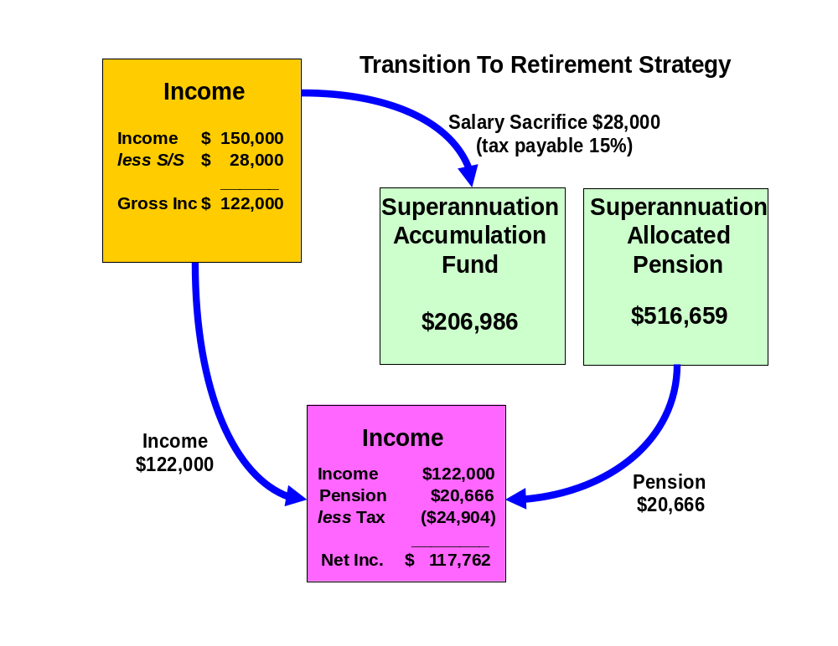

Reversionary Pensions

Recommendations:

Michael, when you commence your pre-retirement income stream (pension) you should make it reversionary.

Benefits:
- A reversionary pension enables your tax dependant beneficiary to receive your pension account balance remaining within the superannuation environment. All moneys received by the reversionary beneficiary remain in pension phase and therefore all income earned by the fund or capital gains realised by the fund to pay the benefit pension will not be subject to tax.
- If either the deceased or the recipient of the reversionary pension is over the age of 60, the income stream will not be assessable for income tax purposes.
Risks:

- Death benefits in the form of a pension may only be paid to a “Tax Dependant”. As your children are not classified as a tax dependants, in the event that you were both to die, they would only be able to receive a lump sum, thus would not receive the benefits of being in pension phase or within superannuation.
- If the income stream is commuted (either rolled into an accumulation fund or lump sums are withdrawn) within six months after the death of the deceased or 3 months after the grant of probate of that deceased person's will or letters of administration of that deceased person's estate, then it is treated as a death benefit payment. Therefore the moneys would be treated as a lump sum benefit outside of the superannuation environment.

Superannuation Contribution Limits

Table 1- Concessional contribution limits

Concessional contributions include employer and self-employed contributions such as salary sacrifice, superannuation guarantee and personal concessional contributions.

Date | Limit (per annum)
Date | To Age 49 | Age 50-59 | Age 60-65 | Age 65-74* | Age75 and over
From 1 July 2012 | $25,000 | $25,000 | $25,000 | $25,000 | SGC only
From 1 July 2013 | $25,000 | $25,000 | $35,000 | $35,000 | SGC only
From 1 July 2014 | $30,000 | $35,000 | $35,000 | $35,000 | SGC only
From 1 July 2017 | $25,000 | $25,000 | $25,000 | $25,000 | SGC only

*Must be employed at least 40 hours during any consecutive 30 day period in the financial year you would like to make the contributions.

Concessional Contributions were previously known as Deductible Contributions (e.g. Salary Sacrifice).

Table 2 - Non-concessional contribution limits

Date | Limit on after-tax contributions | Eligibility Requirements
Date | Limit on after-tax contributions | Under age 65 | Age 65 to 74 | Age 75 and over
From  1 July 2007 | $150,000 p.a. | May bring forward two years of contributions to make a $450,000 contribution in one financial year | Must be employed | Cannot contribute
From  1 July 2014 | $180,000 p.a. | May bring forward two years of contributions to make a $540,000 contribution in one financial year | Must be employed | Cannot contribute
From  1 July 2017 | $100,000 p.a. | May bring forward two years of contributions to make a $300,000 contribution in one financial year | Must be employed | Cannot contribute

Investment Recommendations

After considering your investment profile, your financial objectives, the current economy and economic trends, we recommend that your funds be invested in the following manner.

Current Portfolio
ASSETS
Superannuation Assets
Michael
Australian Super  AMP Corporate Super  Russell Super Fund  AMP Customs Super | $25,136  $40,054  $451,469  $3,806  $520,465
Patricia
Hesta Super | $203,177
Total Superannuation Assets | $723,643

Total ASSETS | $723,643

NET WORTH | $723,643

Proposed Portfolio
ASSETS
Superannuation Assets
Michael
AMP Customs Super  Australian Super  AMP Corporate Super  Russell Super Fund | $3,806  $0  $0  $0
Colonial FirstChoice Wholesale Pre-Retirement Pension
CFS WS Index Australian Share  BT Wholesale Core Australian Share  CFS WS Index Global Share  Realindex WS Global Share  CFS WS Index Property Securities  CFS WS Index Australian Bond  CFS Wholesale Cash Fund | $133,298  $88,865  $77,499  $51,666  $87,832  $67,166  $10,333  $516,659
Patricia
Hesta Super | $203,177
Total Superannuation Assets | $723,643

Total ASSETS | $723,643

NET WORTH | $723,643

Projected Portfolio Compared To Benchmark

Asset Class | Projected Portfolio | Benchmark Profile for Growth | Deviation
Australian Shares | 43% | 43% | 0%
International Shares | 25% | 25% | 0%
Property | 17% | 17% | 0%
Fixed Interest | 13% | 13% | 0%
Cash | 2% | 2% | 0%
Other | 43% | 43% | 0%

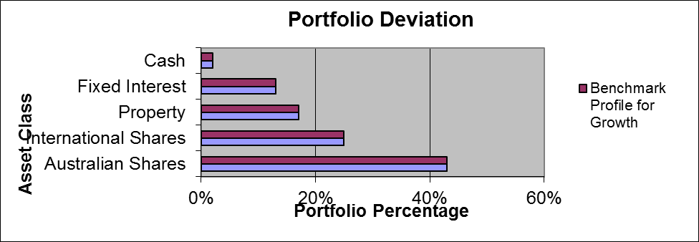

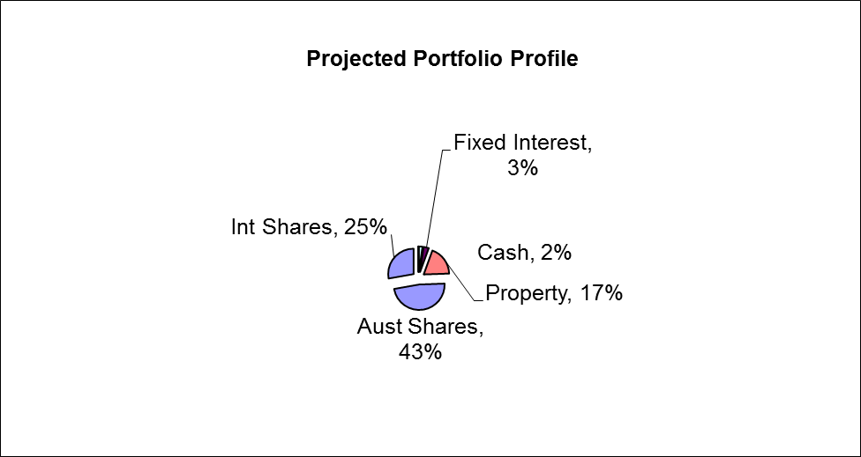

As an industry standard, a variance of 10% within a particular asset class is allowed to cater for individual circumstances, economic events and fund manager asset allocation decisions. Variations outside of this range may be appropriate in certain circumstances.
This said, considering your deviation is away from the standard in some assets, I have included a commentary for the reasons surrounding this:

- The asset allocation noted above falls outside the Investor profile guidelines for a Moderately Conservative Investor. This is due to the fact that our discussions subsequent to your completion of the Investor Risk profile indicated that you would prefer to have your superannuation portfolio invested entirely in the Fixed Interest and cash asset classes.
Colonial FirstChoice Wholesale Investments
The FirstChoice Investments is a multi-manager investment solution which combines wide investment choice with a competitive and simple fee structure, backed up by a high standard of service support from Colonial First State.

A minimum total investment of $5,000 ($1,500 for super) is required to establish an account in FirstChoice Investments. A $1,000 minimum initial balance is required if a regular investment plan is set up at commencement of the account. The minimum regular investment plan amount is $100 per month.

Reasons and Benefits
The major features of the Colonial FirstChoice Investments are as follows:

Sector Specific Diversification
A strong range of investment options with access to more than one specialist manager within each asset class. This approach captures the competitive advantages of each manager. We anticipate this will provide higher returns than can be obtained from using diversified funds with, say, only one fund manager.

Simplicity
Consolidated reporting from Colonial First State.

Ease of Management
Automatic investment re-balancing and switching to help you easily and conveniently keep your investment strategies on track.

- We recommend that annual automatic rebalancing is elected.

Highly competitive and simple to understand fee structure
- No entry fee applies to this investment however, with your agreement; your Financial Adviser may wish to charge a one off fee for upfront costs.
- You can agree with your Financial Adviser to have an ongoing Adviser Service Fee for advice paid directly from your investment. The ongoing fee will be deducted monthly from your investment options.
  - Our normal 0.50% p.a. Adviser Service fee will apply.
- No switching fees or exit fees apply to this investment.

Replacement of an Existing Product

Type of Fee or Cost | AMP Corporate | Russell Super Fund | Australian Super | Colonial Wholesale Pension Fund
Contribution/Entry fee – this is the fee for initial and subsequent contributions. | Nil | Nil | Nil | Nil
Withdrawal/Exit Fee – this is the fee for each withdrawal you make | $36.90 | $80.60 | $35.00 | Nil
Switching Fee – fee charged for switching between investment options in the super fund. | Nil | Nil | Nil | Nil
Administration Costs – are the fees and costs that cover the operation of the fund. They include admin, member and other fees charged by the product issuer | $87.36 p.a. | 0.30% p.a. $83.75 p.a. | $78.00 p.a. | Nil
Adviser Service Fee – additional fee paid to financial adviser | 0.44% p.a. | Nil | Nil | 0.50% p.a.
Investment Costs – are the fees and costs the product issuer charge for investing the assets. These include fees paid to external fund mgrs. | 1.08% p.a. | 0.51% p.a. | 0.87% p.a. | 0.60% p.a.
Annual average cost – on Total $516,659 investment | $7,941 p.a. | $4,269 p.a. | $4,573 p.a. | $5,674 p.a.

The investment cost will vary depending on which fund you are invested in, the assets it invests into and how actively they manage their portfolios, amongst other things. Typically these costs should not be compared directly.

Outcomes Post Recommendation:

- You will gain access to a portfolio of funds that matches your investor risk profile and investment objectives.
- You will gain access to a pension fund which provides the benefits that we have previously outlined.
- You will have the ability to implement the documented strategies and have these reviewed on a regular basis.

Note:

- Whilst the overall fee structure of the proposed Colonial Wholesale Pension Fund is higher than the current Russell and Australian Super funds, the historical performance of the respective funds detailed on the following page suggests that future performance of this actively managed fund is expected to outweigh the higher fee structure.

Performance

A comparison of the performance of the current and proposed funds to 30/04/17 is provided below:
Current Russell Super Fund

1 year | 3 years (p.a.) | 5 years (p.a.)
10.82% | 7.49% | 9.18%

Current AMP Corporate Super fund

1 year | 3 years (p.a.) | 5 years (p.a.)
5.36% | 5.42% | 4.42%

Current Australian Super Fund

1 year | 3 years (p.a.) | 5 years (p.a.)
12.79% | 9.44% | 10.87%

Proposed Colonial First State Growth Portfolio
Asset Class | % of Portfolio | 1 Year (p.a.) | 3 Year (p.a.) | 5 Year (p.a.)
CFS WS Index Australian Share | 26.00% | 21.40% | 8.76% | 12.40%
BT Wholesale Core Australian Share | 17.00% | 19.18% | 9.66% | 12.79%
CFS WS Index Global Share | 15.00% | 15.54% | 12.37% | 16.01%
Realindex WS Global Share | 10.00% | 19.13% | 10.65% | 14.21%
CFS WS Index Property Securities | 17.00% | 6.04% | 16.59% | 16.72%
CFS WS Index Australian Bond | 13.00% | 1.67% | 4.56% | 4.62%
CFS Wholesale Cash Fund | 2.00% | 2.22% | 2.30% | 2.65%
Total | 100.00% | 13.99% | 9.88% | 12.63%

Colonial FirstChoice Management Fee
Colonial FirstChoice charges a Management Expense Ratio to cover their administration costs and the associated costs of managing your funds. Based on your current portfolio value, we have provided an estimation of the costs you will pay.

Michael  Colonial First State FirstChoice Wholesale Pension | MER  % | Amount invested  $ | Estimated  fee  $
CFS WS Index Australian Share | 0.44% | $133,298 | $587
BT Wholesale Core Australian Share | 1.04% | $88,865 | $924
CFS WS Index Global Share | 0.56% | $77,499 | $434
Realindex WS Global Share | 0.81% | $51,666 | $418
CFS WS Index Property Securities | 0.44% | $87,832 | $386
CFS WS Index Australian Bond | 0.44% | $67,166 | $296
CFS Wholesale Cash Fund | 0.44% | $10,333 | $45
Total ongoing fees | 0.60% | $516,659 | $3,091

Please note that there is an additional adviser service fee of 0.50% that is paid by you.
Additional details of the above fees are outlined in Colonial’s Product Disclosure Statement.

Income Tax & Cash Flow Projections Post Recommendation

Proposed Estimated Tax Liability for Michael (full financial year)

Income Source |  | Amount Received | Deduction | Taxable Income | Tax
Salary |  | $90,000
Tax free Pension Income Stream |  | $20,666
Deductions
Salary Sacrifice |  |  | $16,000
TAXABLE INCOME |  |  |  | $74,000
Tax payable before rebates and credits |  |  |  |  | $15,597
Medicare Levy |  |  |  |  | $1,480
NET TAX |  |  |  |  | $17,077

Proposed Estimated Tax Liability for Patricia (full financial year)

Income Source |  | Amount Received | Deduction | Taxable Income | Tax
Salary |  | $60,000
Deductions
Salary Sacrifice |  |  | $12,000
TAXABLE INCOME |  |  |  | $48,000
Tax payable before rebates and credits |  |  |  |  | $7,147
Medicare Levy  Low Income Tax offset |  |  |  |  | $960  ($280)
NET TAX |  |  |  |  | $7,827

Proposed Estimated Cash Flow

Based on your stated income, expenses and current tax position we estimate your cash flow over one whole financial year to be as follows.

 | Michael | Patricia | Total
Income
Salary | $90,000 | $60,000 | $150,000
Pension Income Stream | $20,666 | $0 | $20,666
Sub Total | $110,666 | $60,000 | $170,666
Less Income Tax | $17,077 | $7,827 | $24,904
Less Current Salary Sacrifice | $16,000 | $12,000 | $28,000
Net Income | $77,589 | $40,173 | $117,762
Less Budgeted Expenditure | $67,268 | $47,853 | $115,121
Income Surplus | $10,321 | ($7,680) | $2,641

What is paid to your adviser

Plan Fee
You have agreed to a Plan Fee of $3,300 (inclusive of GST), which will be deducted from your superannuation fund.

Upfront and Ongoing Fee Disclosure

The following is provided to assist you to gain a clear understanding of the payments and benefits that Pareto Group Pty Ltd, our associates and I will be entitled to receive for services provided to you, if you adopt the recommendations in this plan.

There is an entry fee payable of which the break-up of the fee is disclosed as follows:

 |  |  | Total Fee Paid by Client |  | Total Payable to Financial Service Licensee/Financial Adviser and /or its Associates
Investment Details |  | Amount Invested | (%) ($) |  | Initial  (%) ($) |  | Ongoing  (%) ($)
Colonial FirstChoice Wholesale Pension |  | $516,659 | Flat Fee | $3,300 | Flat Fee | $3,000 | 0.50 | $2,583pa
Total |  | $516,659 |  | $3,300 |  | $3,000 |  | $2,583pa

* The ongoing investment amount has been annualised to provide you with a clear picture of how fees are paid from your investment. Your regular contribution is placed into the individual underlying funds according to the % split of the allocation of your original investment.

The agreed Ongoing fee is the way we charge for the ongoing service that we provide. If at any time you wish to discuss this you can do so.

I am an authorised representative of Pareto Group Pty Ltd (ABN 11 155 278 078), which holds an Australian Financial Services Licence (AFSL #418700).

Disclosure Statement

To help you understand the full benefits, details and risks of our recommended products, please read the Product Disclosure Statements that we will provide you.

Please let us know if you have any questions.

Cooling-off periods

After investing in a financial product, you have a “cooling-off” period in which to change your mind if you don’t think the product meets your needs. The cooling-off period usually starts when you’re told the product has been set up. The length of the period varies with each product.

Each Product Disclosure Statement explains your cooling-off rights.

If you wish to cancel a product, please tell us in writing so we can contact the product issuer within the time restrictions.

No guarantee

The investments we recommend for you must be appropriate for you. However, we don’t guarantee they’re the best available or that they’ll perform in a particular way. Product performance depends on the features and risks described in the Product Disclosure Statements given to you.

Please take the time to read the PDS and understand the products we have recommended. If you have any questions, please contact us.

Tax

There will be tax implications if you act on this advice. We recommend you ask a tax professional to assess the impact on your short and long-term financial positions.

Are My Product Recommendations Restricted?

Non Superannuation Products

Yes, when making non superannuation product recommendations I can only choose products from our Approved Product List (APL). This list is compiled by a dedicated Investment Committee, made up of Research Manager, Directors and Representatives who carefully analyse investment products, prior to including any product on the APL. The Committee utilises leading industry research houses to assist with their analysis.

The APL is regularly reviewed to ensure that all funds, managers and investment companies continue to meet our ongoing stringent requirements.

Superannuation Products

Yes, when making superannuation product recommendations I can only choose products from our Approved Product List (APL). However, if you have a superannuation product that is not on our APL, I am still able to make recommendations in relation to that fund providing I have conducted the necessary research and have a thorough knowledge of the fund.

What is My Responsibility to You?

I am responsible for providing you a ‘clear, concise & an effective’ method of communicating my recommendations to you. The recommendations are based on your goals and objectives, personal and financial situations, and other information collected from you. The recommendations are appropriate for your needs and current situation.

As the SoA is specifically prepared for you and based on your situation, I do not take any responsibility for any third party persons acting on all or on a part of any advice or recommendations made in this SoA.

Do I Guarantee the Investments I have recommended?

No. By law, the investments I have recommended must be appropriate to you, however, I do not guarantee that the recommended investments are the best for you or that they will perform in a certain way.

Your Financial Plan

In preparing this plan we have taken into account your specific goals and objectives, and have designed an appropriate strategy that aims to accomplish these.

It is important to appreciate that we live in an ever changing world. Accordingly, it is probable that, overtime, the basis of our calculations (inflation rates, investment rates etc) will change, as will your own requirements and expectations. It is therefore recommended you review your plan on a regular basis to ensure you are still on track to achieve investment objectives.

It is essential to have your investment portfolio reviewed to ensure that the investments are working to their maximum potential and any changes to the investment markets, taxation etc. are promptly and correctly responded to.

Next steps

How to get started

To implement our recommendations in this plan, please do the following:

- Make sure you read this Statement of Advice and Product Disclosure Statements
- Contact us if you have any questions
- Tell us immediately if any information is incorrect
- Complete the application forms in the Product Disclosure Statements
- Sign and date the Authority to Proceed
- Return the forms to us
- Retain a copy for your records

Finally

Please note, as with any investments, their future value may fluctuate, particular rates of return cannot be guaranteed and you may not get back what you originally invested. We have provided a brief summary of the managed investment products recommended, however, you will need to study the investment statements of the recommended products carefully before you decide to invest.

Summary

Plan Implementation

Michael and Patricia, you have taken another next step to reach your personal and financial goals and objectives. The most important stage of the process is to put the plan into action. There are a number of steps required for the implementation of this plan:

Action | Anticipated Start Date | Estimated Completion Date | Responsibility
Detailed review of the recommendations | 7 June 2017 | 7 June 2017 | Michael, Patricia
Authority to Proceed returned with any amendments | - | 7 June 2017 | Michael, Patricia
Applications returned | - | 7 June 2017 | Michael, Patricia
Pension Application Process | 21 June 2017 | 12 July 2017 | Andrew Lord
Confirmation of all in place | - | 19 July 2017 | Andrew Lord
Book Post-Implementation / Review Appointment | - | 7 June 2018 | Michael, Patricia,  Andrew Lord

Authority to Proceed

We, Michael & Patricia McMillan, of
5 Anvil Place
ATTWOOD VIC 3049

State that:

I have read and understood the Financial Plan presented to me by Andrew Lord B Bus (Acc), Dip FS (Fin Plan) from Pareto Group Pty Ltd, and authorise him to proceed with the recommendations as outlined below:

Investment | Amount
Michael - Colonial FirstChoice Wholesale Pension | $516,659

All fees and charges have been explained to me.

I authorise Andrew Lord B Bus (Acc), Dip FS (Fin Plan) to act in his capacity as our Financial Adviser regarding this investment and to act on our instructions provided by (tick whichever is applicable):

- Facsimile

- Email

- Writing

I acknowledge that:

- I have received and read a Financial Services Guide.
- I have provided all information to the best of my knowledge for the preparation of this Statement of Advice.
- My adviser is not a taxation adviser, and estimates of tax positions are estimates only.
We should seek advice from a registered tax agent for taxation advice.

q I accept the recommendations made in this Report and give authority to Pareto Group Pty Ltd ABN 11 155 278 078 to proceed with the implementation of those recommendations.

Modifications to recommendations requested by client

Signed: | _________________________________ | ____/______/______
 | Michael McMillan | Date
Signed: | _________________________________ | ____/______/______
 | Patricia McMillan | Date

Signed: | _________________________________ | ____/______/______
 | Andrew Lord  B Bus (Acc), Dip FS (Fin Plan) | Date

